GOLFING SOCIETY PHOTOGRAPHS 2010

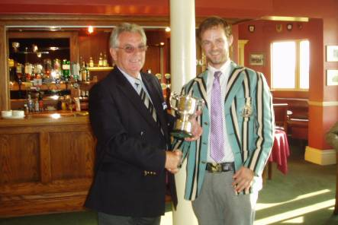

Michael Coffey (OSBGS President) presenting John Currie with the Critchley Cup

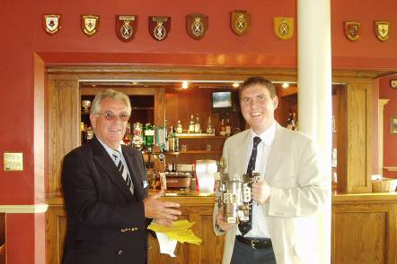

Michael Coffey (OSBGS President) presenting Chris Lamont with Farquie’s Fortifier

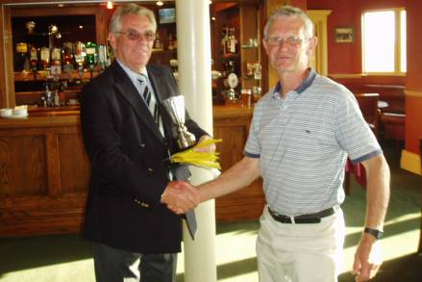

Michael Coffey (OSBGS President) presenting Jonathon Crosland
with the Dick Harrison Cup

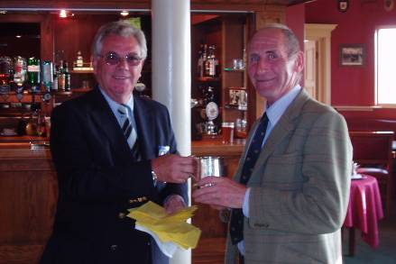

Michael Coffey (OSBGS President) presenting Neil Morton with the Ken Case Tankard

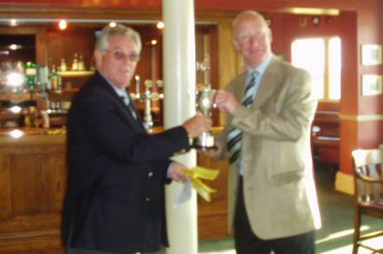

Michael Coffey (OSBGS President) presenting Mark Morrison with the Bill Fox Cup

